Unsigned Binary Division

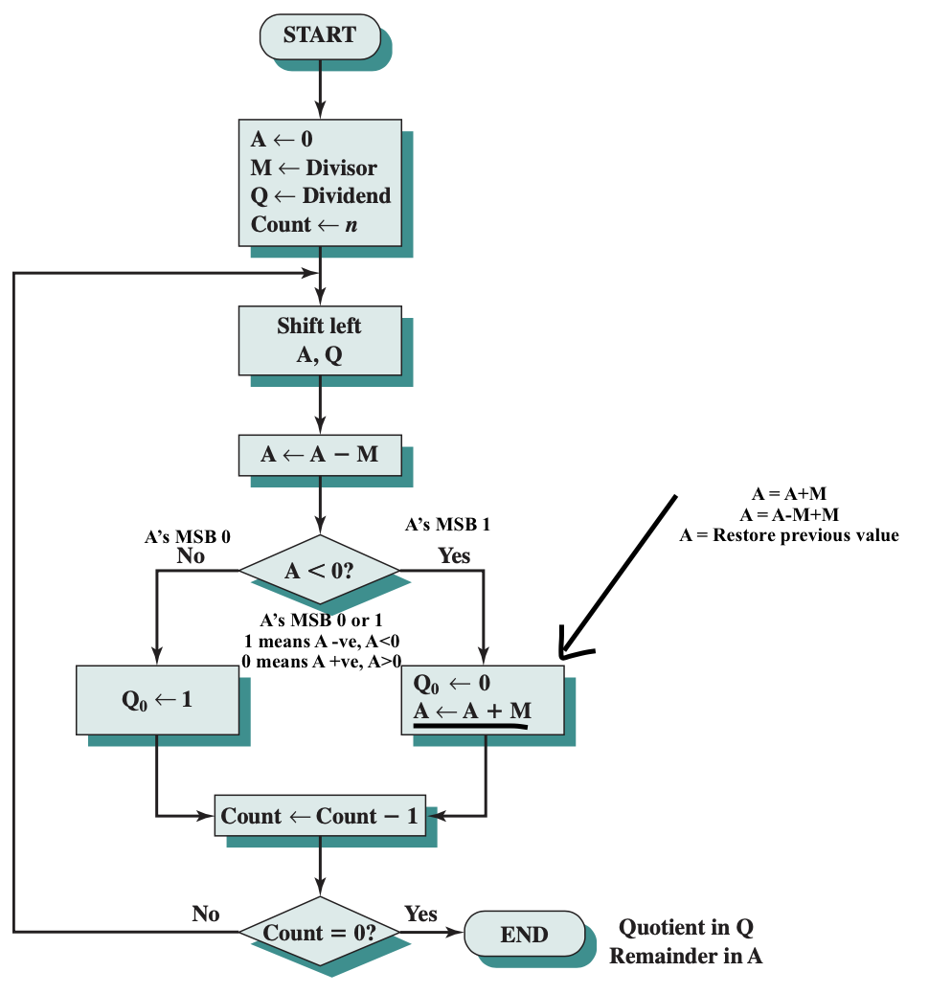
Fig: Unsigned Binary Multiplication

Division example: 7/3
Q = 7 = 0111
M = 3 = 0011
- M = 2’s complement of 3 = 1100+1 = 1101
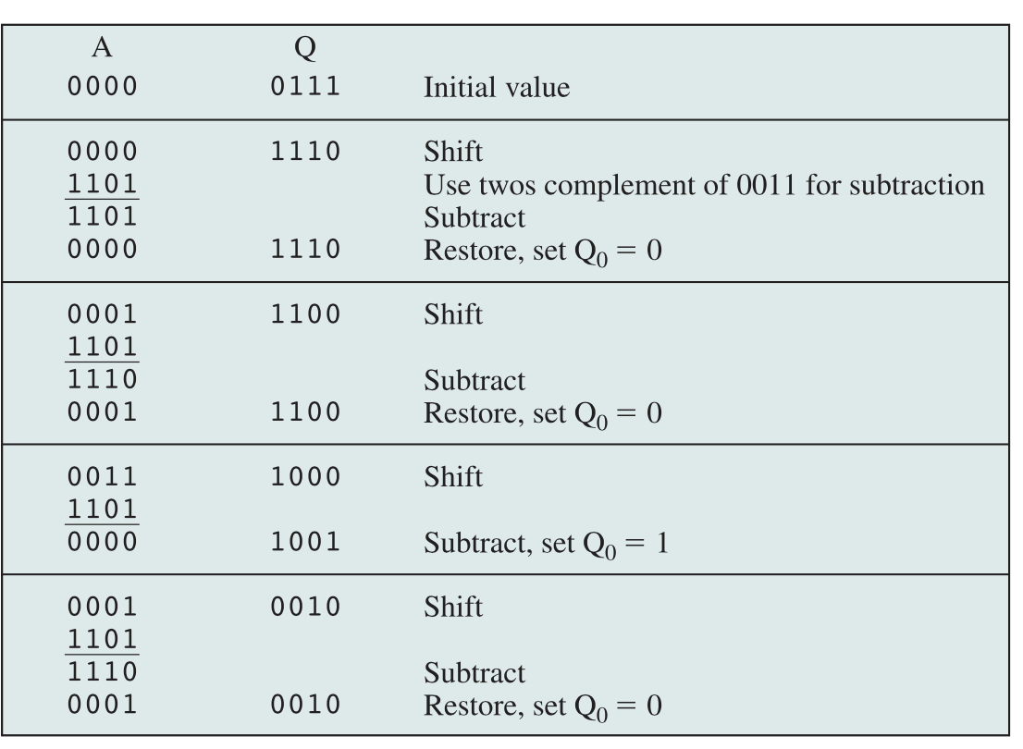
Here,
Remainder in A = 0001
= 1
Quotient in Q = 0010
= 2
2’s Complement Division

- Divisor is loaded in M, dividend in A and Q register.
- Dividend must be expressed as twice n bit 2’complement number.
For example,
- in $-$7/3
Dividend = $-$7 = 1001 (n bit 2’s complement number)
Here, M = 1111 1001 (twice n bit 2’s complement number)
- in 7/3
Dividend = 7 = 0111 (n bit 2’s complement number)
Here, M = 0000 0111 (twice n bit 2’s complement number)
- Shift A, Q left 1 bit position.
- If M and A has same sign, i.e., MSBs are same
Perform A A$-$M
Else Perform A A$+$M
- If the operation is successful
i.e., sign of A is same before and after operation
Set $Q_{0}$ 1
Else if Sign of A changes
Set $Q_{0}$ 0 and
Restore previous value of A
- Repeat the above steps for number of bits in Q. Remainder is in A. if the sign of the divisor and dividend are same, the quotient is in Q, If the sign are different, the correct quotient is 2’s complement of Q.
Q. Perform $-7/3$
Ans: Dividend = $-$7 = 2’s complement of (0111) = 1001
Dividend (in 2n bit) = 1111 1001
So, A = 1111 Q = 1001
Divisor = M = 3 = 0011
$-$M = 1101
Count | A | Q | M | Remarks
4 | 1111 | 1001 | 0011 | Inital
3 | 1111 | 0010 | 0011 | Log. Shift left, A&M $-+$
3 | 0010 | 0010 | 0011 | A A$+$M, A&A $-+$
3 | 1111 | 0010 | 0011 | $Q_{0}$ = 0, Restore A = 1111
2 | 1110 | 0100 | 0011 | Log. Shift left, A&M $-+$
2 | 0001 | 0100 | 0011 | A A$+$M, A&A $-+$
2 | 1110 | 0100 | 0011 | $Q_{0}$ = 0, Restore A = 1110
1 | 1100 | 1000 | 0011 | Log. Shift left, A&M $-+$
1 | 1111 | 1000 | 0011 | A A$+$M, A&A $--$
1 | 1111 | 1001 | 0011 | $Q_{0}$ = 1
0 | 1111 | 0010 | 0011 | Log. Shift left, A&M $-+$
0 | 0010 | 0010 | 0011 | A A$+$M,
0 | 1111 | 0010 | 0011 | $Q_{0}$ = 0, Restore A = 1111
As Remainder is in A,
R = A = 1111
For 2’s complement to decimal conversion

1 | 1 | 1 | 1
$-$8 4 2 1

= $-8+4+2+1$
= $-$1
Remainder = $-1$

Quotient is in Q,
When sign of divisor ($+3$) and ($-7$) are different
Correct quotient = 2’s complement of value in Q
= 2’s complement of 0010
= 1101+1
= 1110
For 2’s complement to decimal conversion

1 | 1 | 1 | 0

$-$8 4 2 1

= $-8+4+2+0$
= $-2$

